Computational Collage

Finding dominant colors

Threshold for dominant colors: 0.07

Should we look at k-means clustering?

http://www.pyimagesearch.com/2014/05/26/opencv-python-k-means-color-clustering/

|  |  |  |  |
| --- | --- | --- | --- |
| https://lh3.googleusercontent.com/Qt3uXeZeiWBEKBeMFj3mRCk0a1Ut1bdeS9nD03M9zex6PuYvII7HtQ4nRayWCSIHONVavwSyA4VowqUC5be3vUCWD54ieGyggT0YkfU1QTnJnogJKgPsJ8WYBARXeGnhCyjHgEg | https://lh6.googleusercontent.com/U7ZInisGPns_84WXU-I3D6dYvjOw3_q3VDk-9BxMwML2oiWGwYQaFI4iuWYNmZ515YvJBY_GwOyPB8yIcDxkeega6UMnCkX7TvxcJOIQ8pkLtBE-SEO8-wg_wX96IFPdFnujoQM | https://lh6.googleusercontent.com/kS4igZBMQakLGi03M6YqvCU6gfMGDxHY0K5d3Ys6xgH9PDmYEdL0TZjiQQd6EGedS0Rw0myuU01BDC7sjDW_seMAlJ8LrCytwvZ9-s3LLu--oDmbC8TGc2p_1ciVVK8j3mgXNFQ | https://lh3.googleusercontent.com/WGHpjViaCJq_v5v4_Z3EHA4Boj6zRJM_QebxU8Zl9b3B2szaFyyxBAuPrThqBUnTikpKuqR_qMSN-rKWkw3w4Yzw0CqRTCLkIP_udDOM8YQ5d8dOln6hOIBRsCza9PpvUEPPvRs |
| https://lh5.googleusercontent.com/mgqkAF4JP_lzutSK1-t-aAzKFVuKrUkhT-iBIpgkHE088mXvWe_z5SZnIHpcJ_Ozkc789ATxsyDmMY9gSf5IIm9hSZukPbMDN8faA8gFA1yvRM3WtxugB-Pfvn4x7i1_vOEu9Rc  [0.093, 0.071, 0.067, 0.058, 0.053, 0.049, 0.049, 0.04, 0.036, 0.036, 0.036, 0.036, 0.031, 0.031, 0.031, 0.027, 0.027, 0.027, 0.022, 0.022, 0.022, 0.018, 0.013, 0.013, 0.013, 0.009, 0.009, 0.009, 0.009, 0.004, 0.004, 0.004, 0.004, 0.004, 0.004, 0.004, 0.004, 0.004, 0.004] | https://lh3.googleusercontent.com/_ePG6l-FysqJtxtaHN0WfCsuLpKwAHkkmQrwZMT7tuShb0YuINKlDHDgDxNOTcfembVxokYkOrbv0ApgO0Izacp2ORtztzMp93kfUDitwPtvm8dfE_GXNMbf3-cdiHzWvP1i-SE  [0.124, 0.098, 0.071, 0.058, 0.044, 0.04, 0.036, 0.031, 0.031, 0.027, 0.027, 0.027, 0.022, 0.022, 0.018, 0.018, 0.018, 0.018, 0.013, 0.013, 0.013, 0.013, 0.009, 0.009, 0.009, 0.009, 0.009, 0.009, 0.009, 0.009, 0.009, 0.009, 0.009, 0.009, 0.009, 0.009, 0.009, 0.009, 0.004, 0.004, 0.004, 0.004, 0.004, 0.004, 0.004, 0.004, 0.004, 0.004, 0.004, 0.004, 0.004, 0.004, 0.004, 0.004, 0.004] | https://lh4.googleusercontent.com/s4a9B1UJLqB40htkwSMXb2beAysktUQ0ADDhILD_ET1hnlxUEct3fWfMs-FO1aIJGW6F0OZ-wIPLJMyVMRdhgsNvgOrX5H92UnMDpT4HCxeVbMOoiOftKJap7eXIJWaScDDRfZ4  [0.316, 0.244, 0.102, 0.067, 0.067, 0.049, 0.031, 0.018, 0.018, 0.018, 0.013, 0.009, 0.009, 0.004, 0.004, 0.004, 0.004, 0.004, 0.004, 0.004, 0.004, 0.004] | https://lh4.googleusercontent.com/kUVqMCBkW9D9r_pnldet7Guko8J2UiQ8vwxNKBqH9jGhaegVip6S5r0GJXFNBjw87OsYX0ze3-Gb8i4I5J7-dbt41I1SqWxF56k58cAsTL7LOvfdF4Rp7tj7BT3jqPVE2IapT4w  [0.089, 0.08, 0.053, 0.053, 0.049, 0.044, 0.036, 0.036, 0.031, 0.027, 0.027, 0.022, 0.022, 0.022, 0.022, 0.018, 0.018, 0.018, 0.018, 0.018, 0.018, 0.013, 0.013, 0.013, 0.013, 0.013, 0.013, 0.013, 0.013, 0.013, 0.009, 0.009, 0.009, 0.009, 0.009, 0.009, 0.009, 0.009, 0.009, 0.009, 0.009, 0.004, 0.004, 0.004, 0.004, 0.004, 0.004, 0.004, 0.004, 0.004, 0.004, 0.004, 0.004, 0.004, 0.004]  Fails over here |

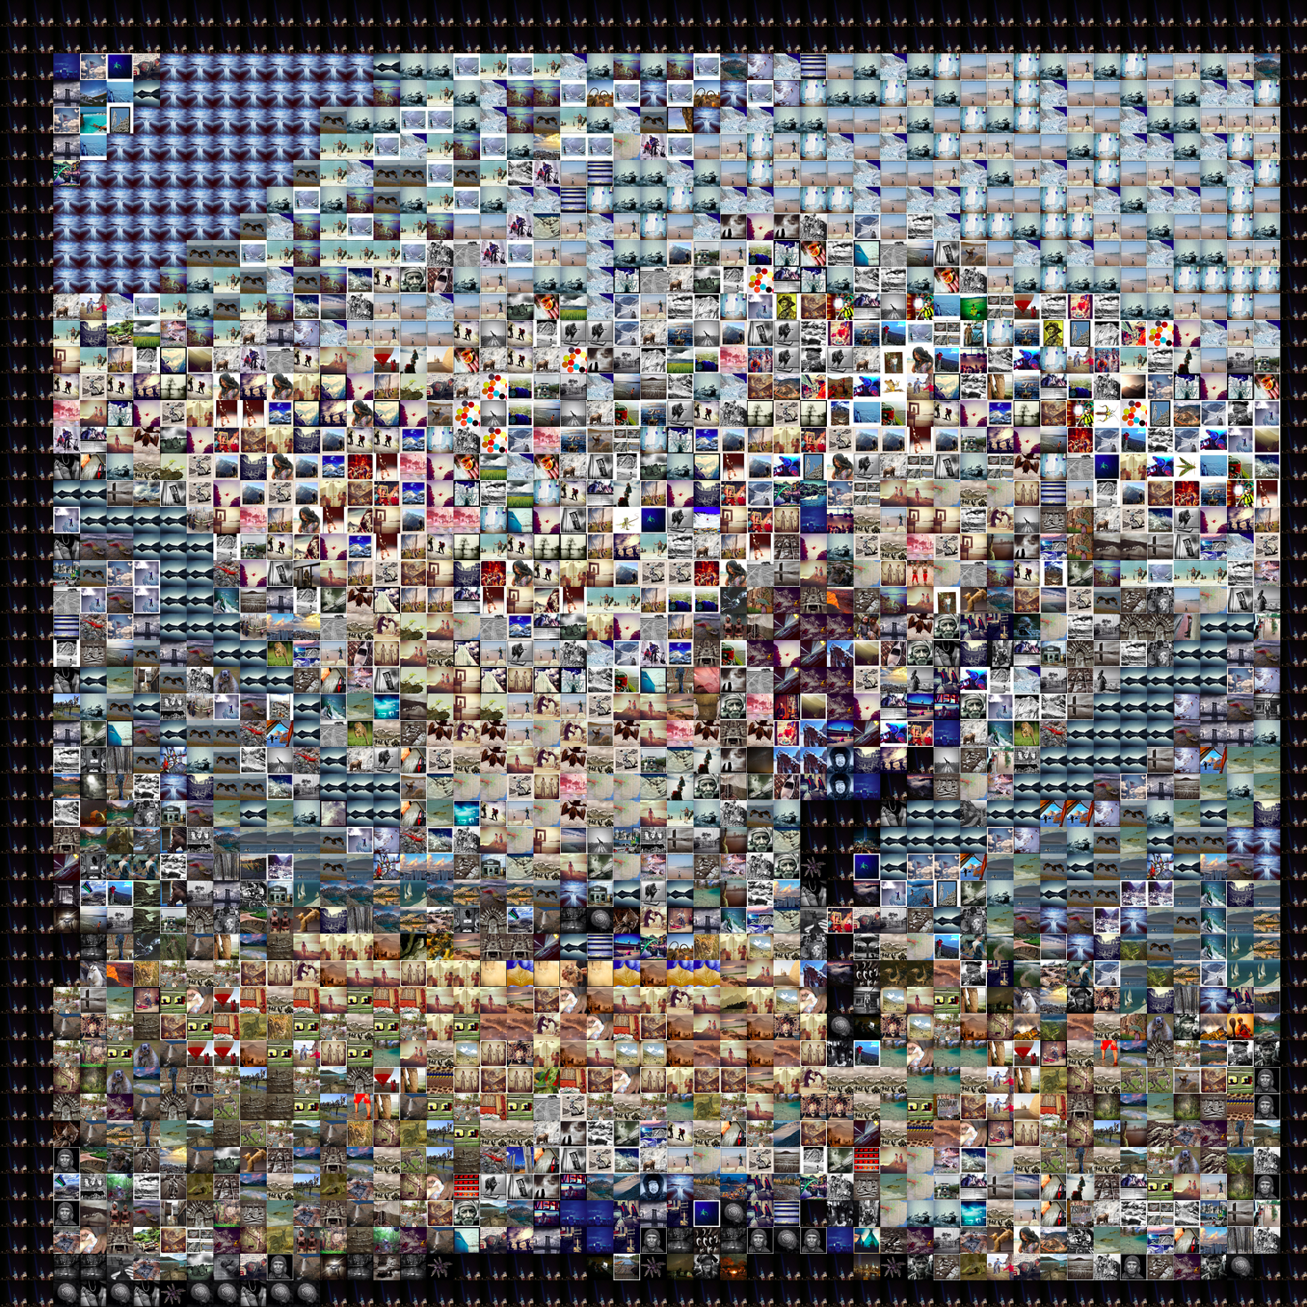

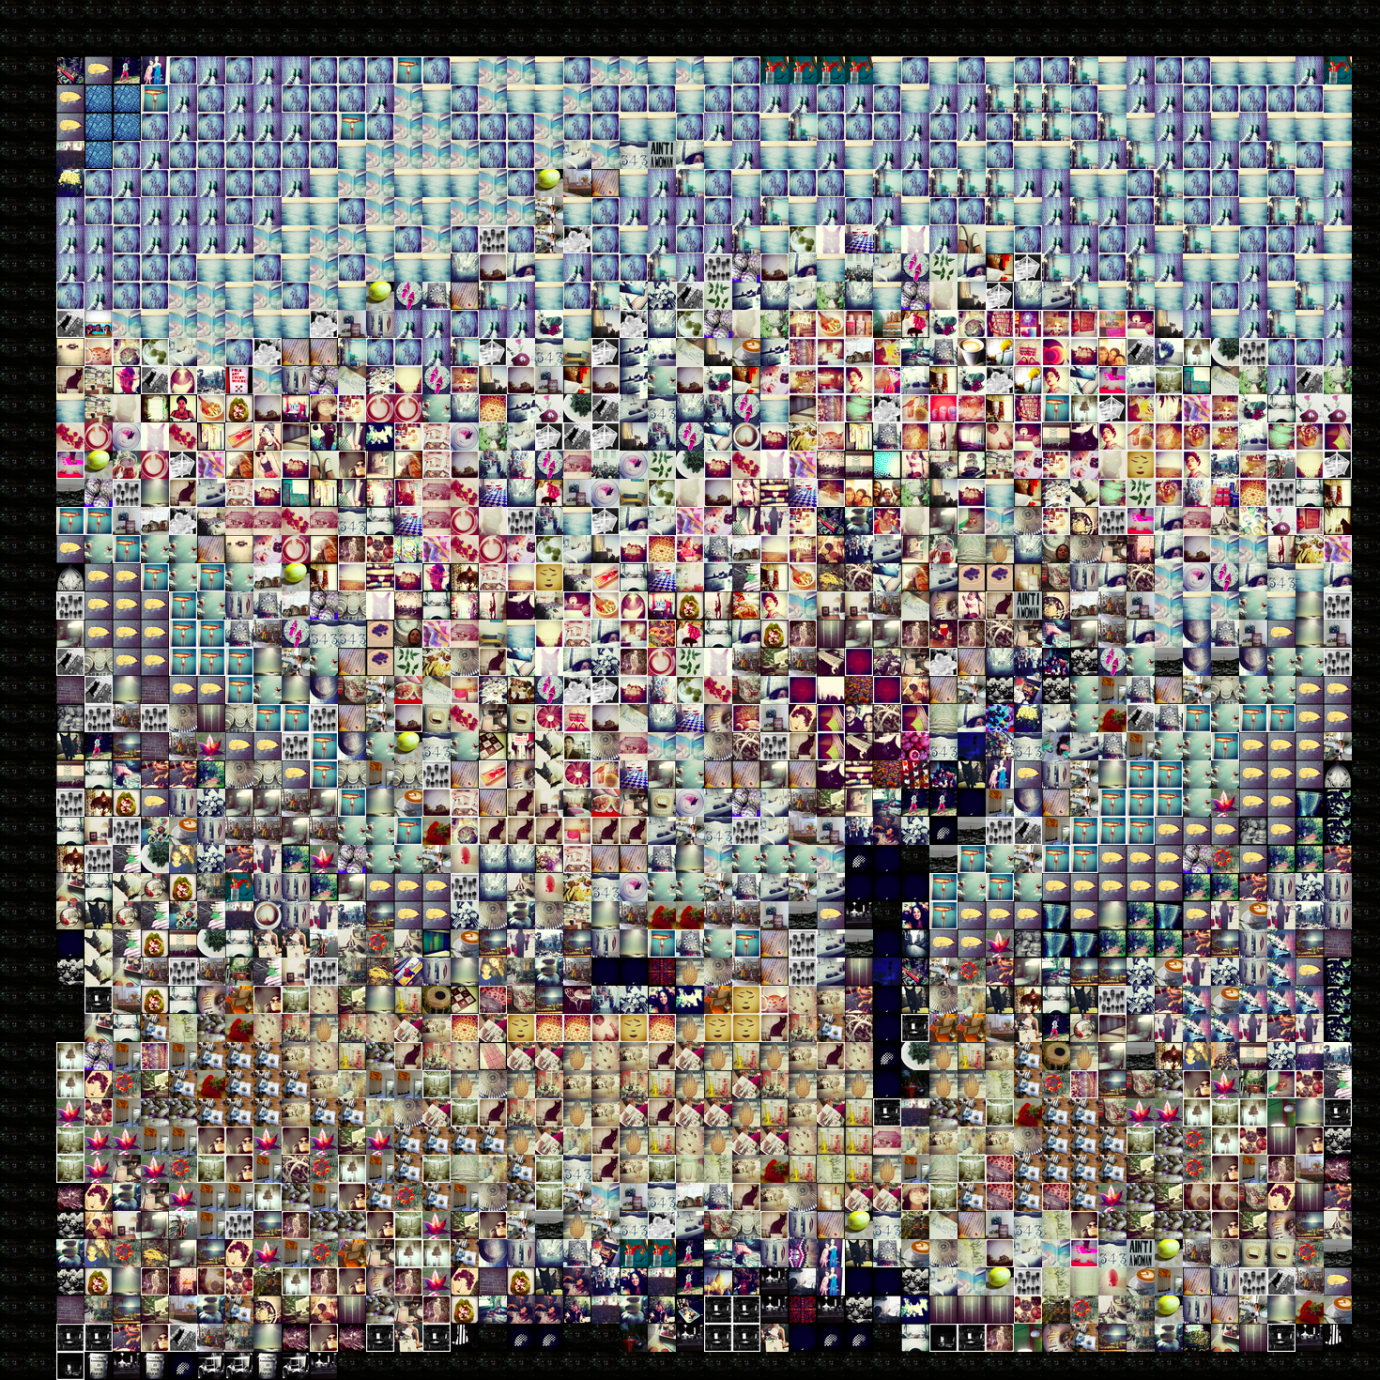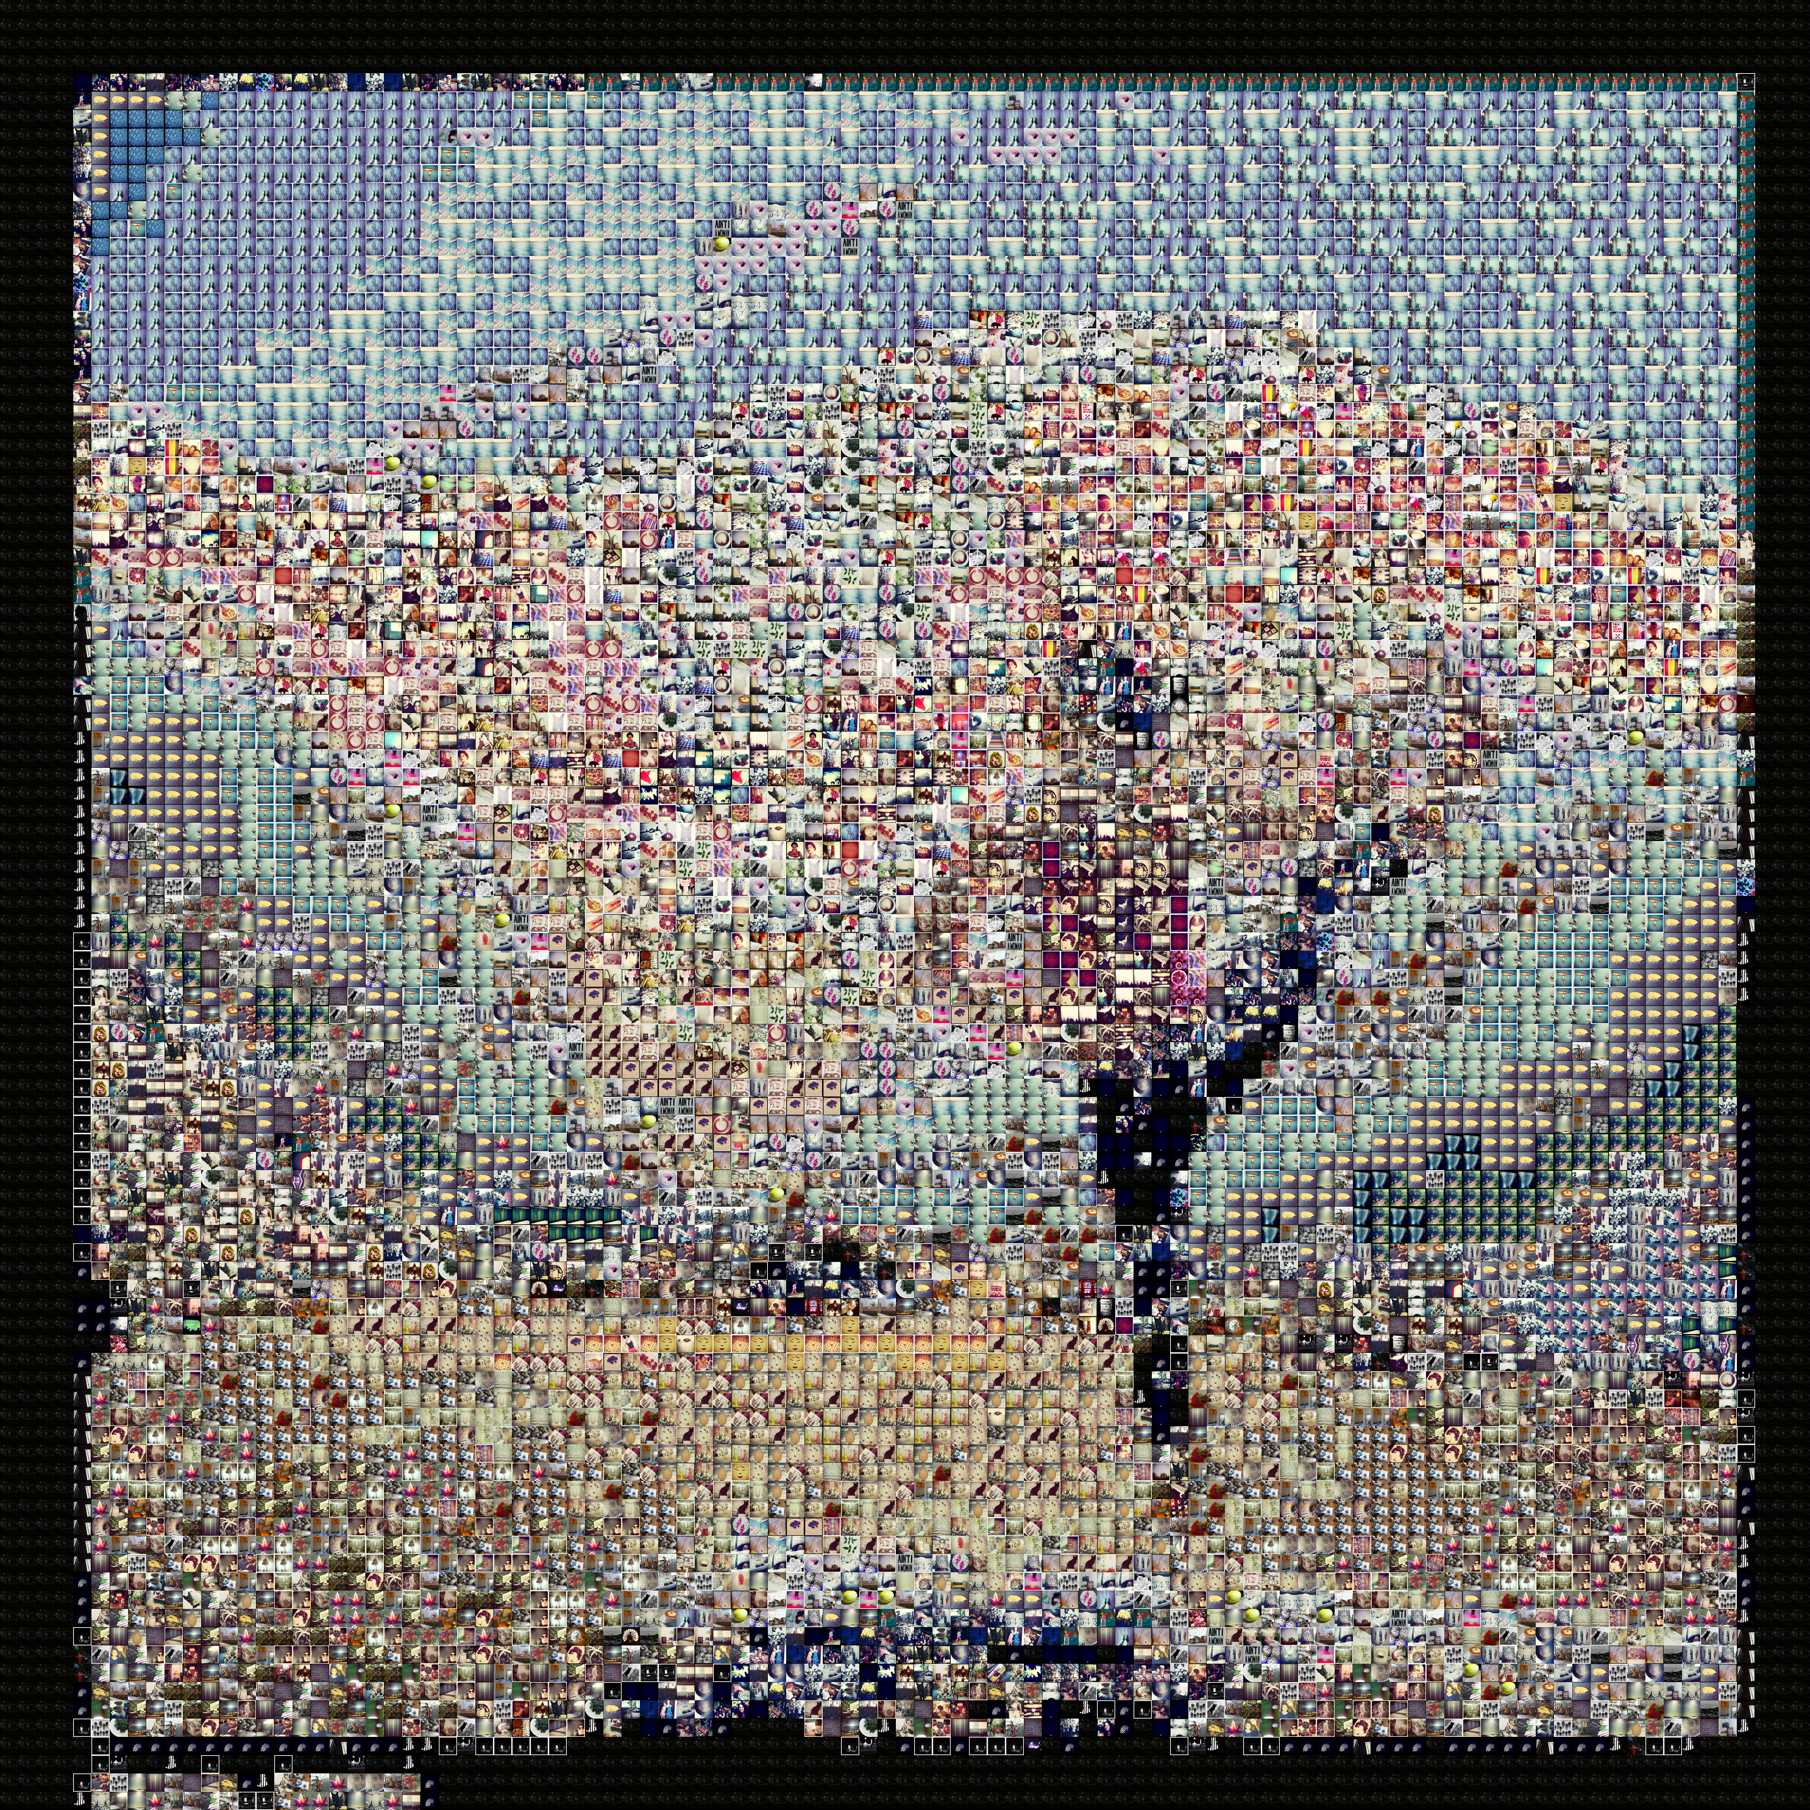 100 columns

second one has a higher percentage requirement for image to be considered best match for black (only if bin-downsized rgb is 0,0,0)

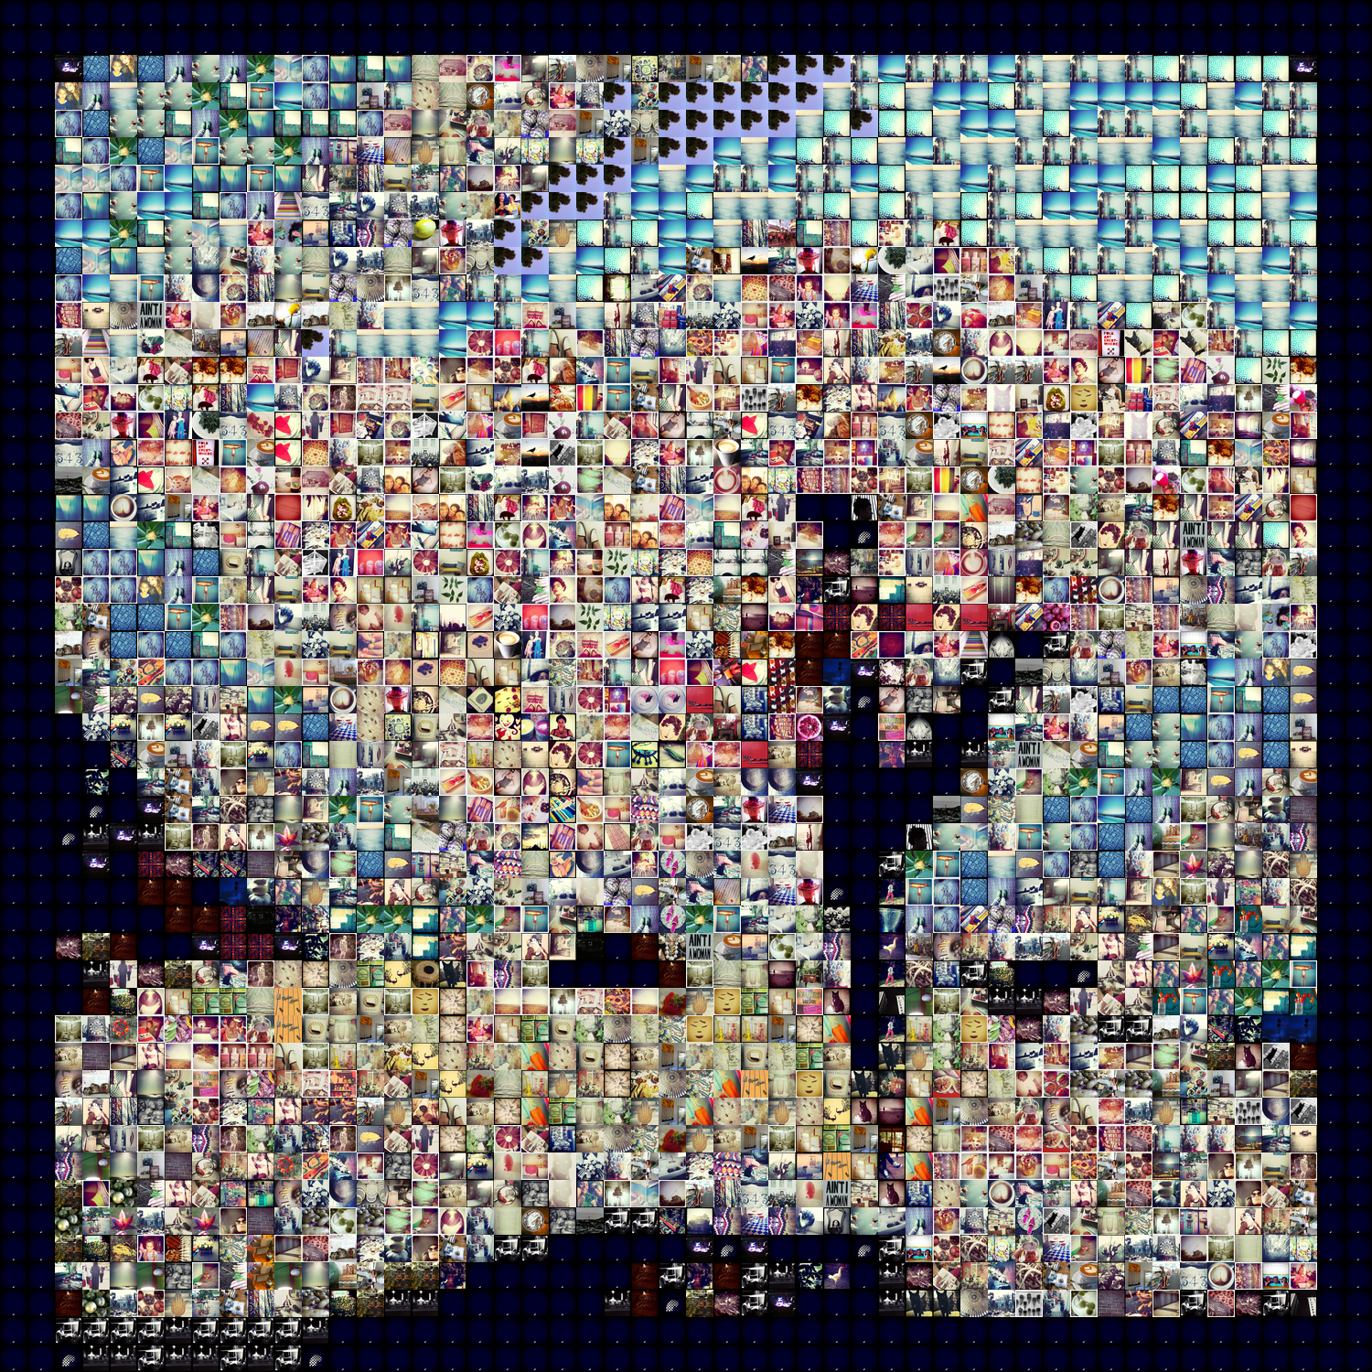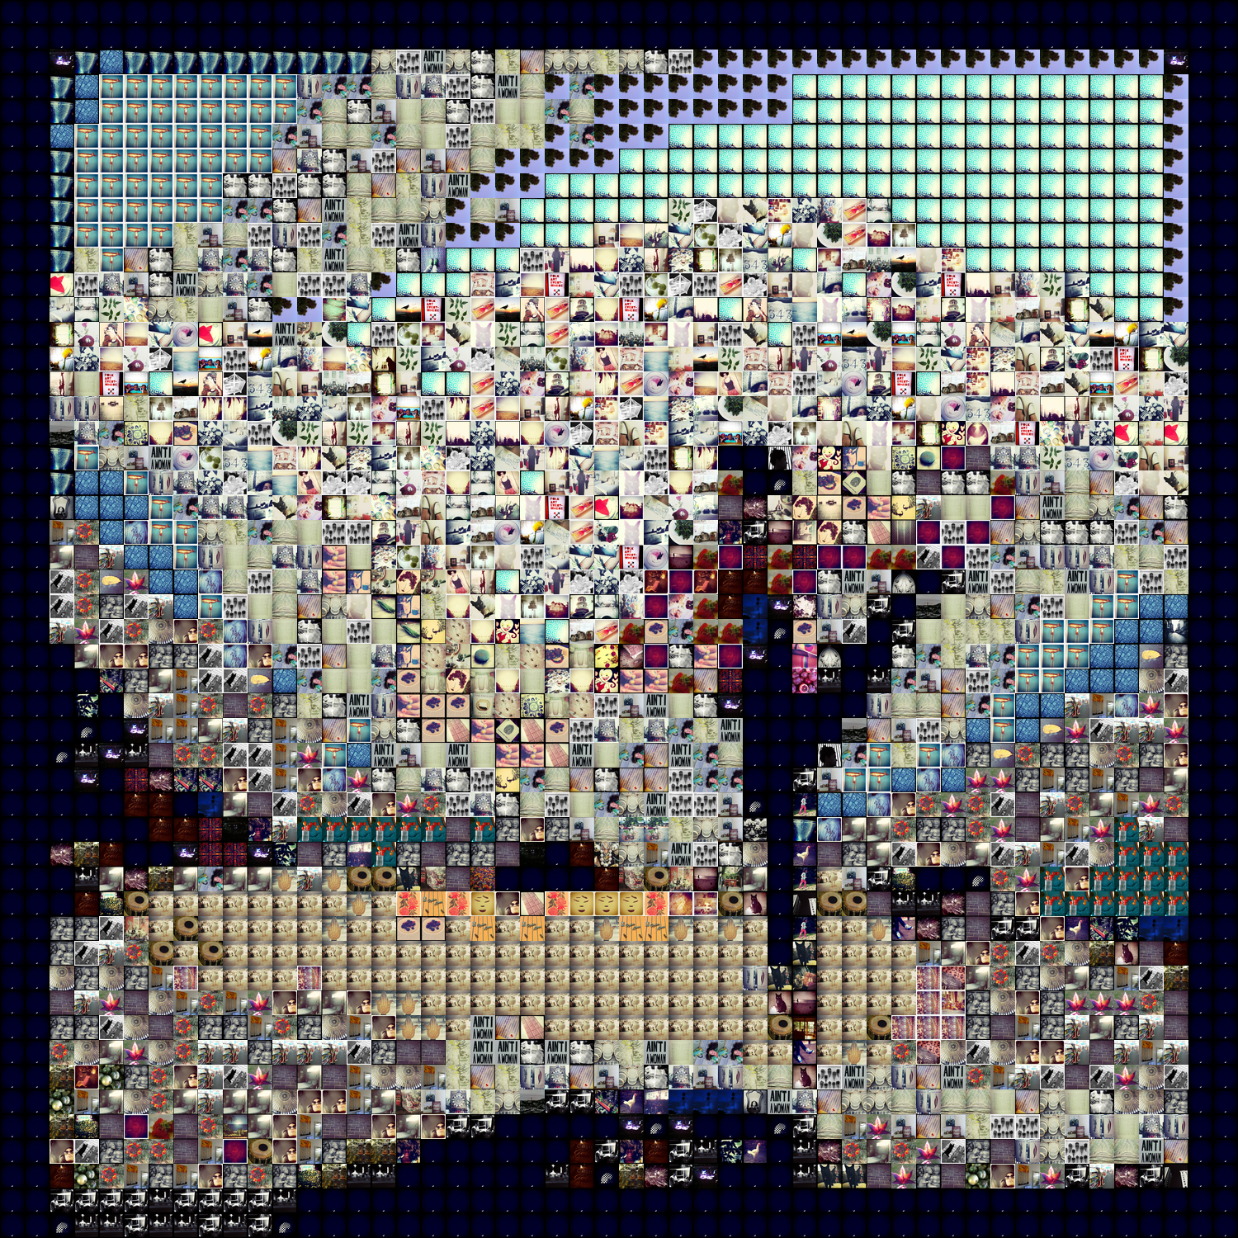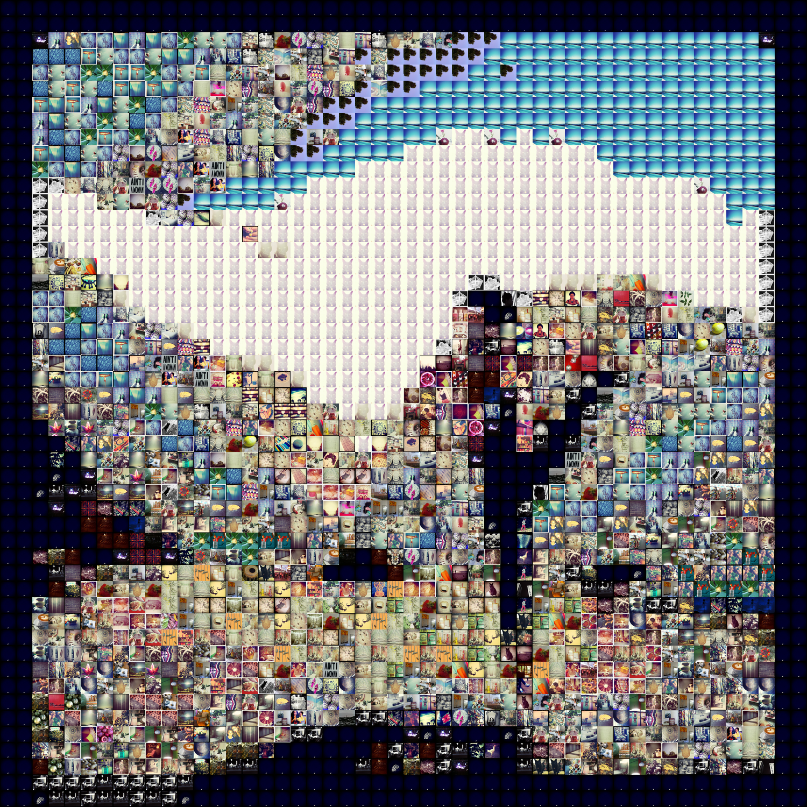

4 bins instead of 8 when min percentage a pixel must have to be considered dominant color is 0.3 instead of 0.1

dealing differently with black and white

Taking out measures of color dominance

Expensive operations: 588 of 2500 : 0.2352

Dominant operations: 0 of 2500 : 0.0

History operations: 1912 of 2500 : 0.7648

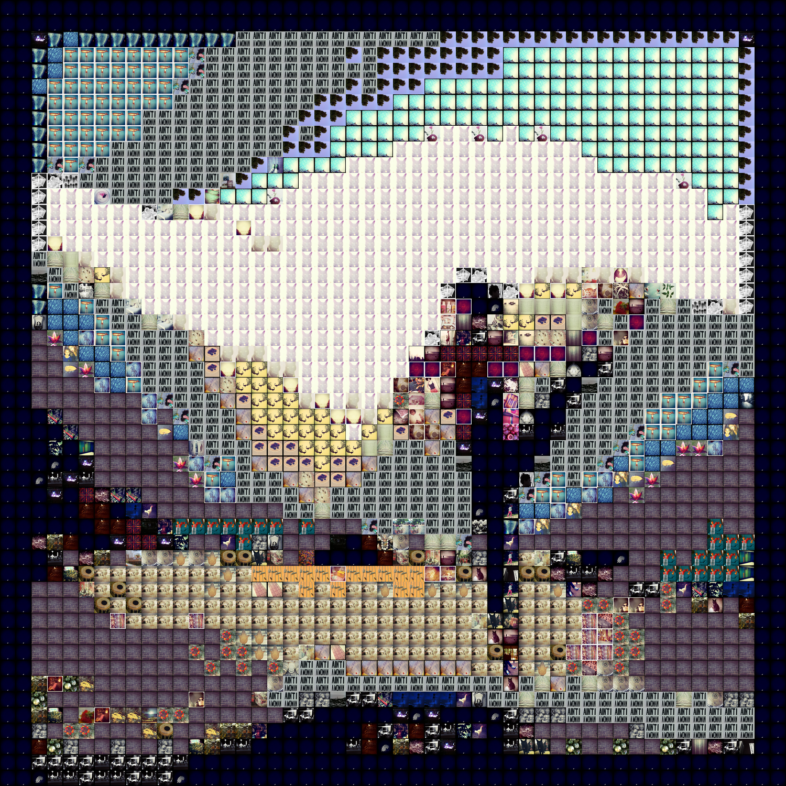 <- something very broken here